**The Power of Validation**

**Saturday, 9th September 2023, 09:00-16:00**

**Spectrum Centre, Inverness**

Presenter: Avigail Abarbanel

(Numbers**:** 25 max. / 12 min.)

(the neuroscience of facilitating

change & growth)

**Booking Form**   
(To book your place, please fill in this electronic form, and email it to **avigail@fullyhuman.co.uk**)

**Full name**

**Full address**

**Phone**

**Email**

**I am a** Psychotherapy Student  Practitioner

**Cost £95** (*I understand that my booking will be confirmed when my payment has been received*). The

fee includes coffee/tea morning & afternoon, a sandwich lunch, materials & CPD certificate.

     

**Signature** *(electronic signature is fine)* **Date**

**Payment Options**

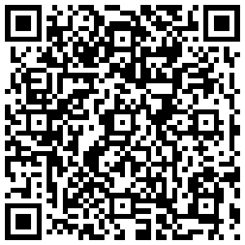

**BACS** Fully Human Psychotherapy

A/C No. 10026794 | Sort Code 40-22-66

**Card** To pay securely by card (via SumUp), please scan this QR code with your phone.

You will be taken to the SumUp site where you can pay by card, (or Google, or Apple Pay).

Alternatively, please contact me at [avigail@fullyhuman.co.uk](mailto:avigail@fullyhuman.co.uk)to receive a **unique payment link** to process a secure card payment via the SumUp website.

**Terms and Conditions (I confirm that I have read & understood the terms and conditions** **)**

Cancellation Policy– Cancellations must be received by email. Conditions: 4 weeks prior to the event – 100% refund. 2-3 weeks prior to the event – 25% of fee applies. Less than 2 weeks prior to the event – 100% of fee applies. Please be aware that if the minimum number (12) to make this workshop viable is not achieved, it will not go ahead, and you will receive a full refund.

Payment Terms- Payment is required to secure your booking. **Non-Attendance** - If you are unable to attend, you may send a substitute at no extra cost.

Photography **–** the workshop may be video-taped but the camera will point only on the speaker.

Data Protection- By submitting your details on this form, you agree to allow Avigail contact you for the purpose of this workshop. In accordance with the GDPR, your personal details will not be retained for any other purpose, nor will they be shared with any other organisation.

Events Beyond my Control- If the event is cancelled due to circumstances beyond my control, the full cost of the workshop will be refunded. If this happens, I will not be liable for any other costs incurred by participants.